ChillnFree

User Interface (UI) Prototype

Version <1.0>

Revision History

| **Date** | **Version** | **Description** | **Author** |
| --- | --- | --- | --- |
| 1/12/2021 | 1.0 | - Detail UI prototype | Trần Ngọc Lam  Đặng Kiệt Hào  Lê Quốc Trọng |
|  |  |  |  |
|  |  |  |  |
|  |  |  |  |

Table of Contents

**Home page** **4**

**Play music page** **6**

**Sign in/Sign up** **8**

**Upload a song** **10**

Figma: [ChillnFree Prototype](https://www.figma.com/proto/xZSv3VQkVUEClmQTKgYmJn/ChillnFree?node-id=17%3A2&starting-point-node-id=17%3A2)

UI Prototype

# Home page

Flow 1:

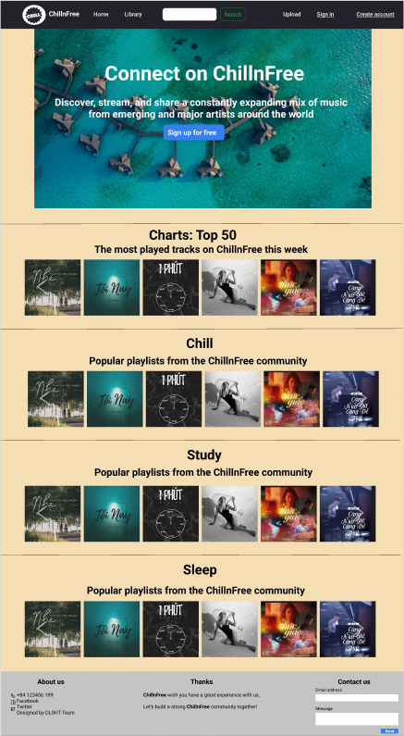

Description: This is the home page when the user is not logged in. In this page the user can sign in, create a new account, search for music. To use the Upload function, users need to sign in to use. In the middle of the page there is some music that is recommended by the website.

Flow 2:

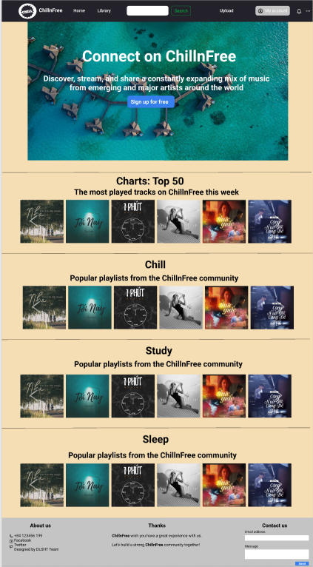

Description: This is the home page when the user is logged in. In this page the user can upload the music, search for music or view the user profile.

# Play music page

Flow 1:

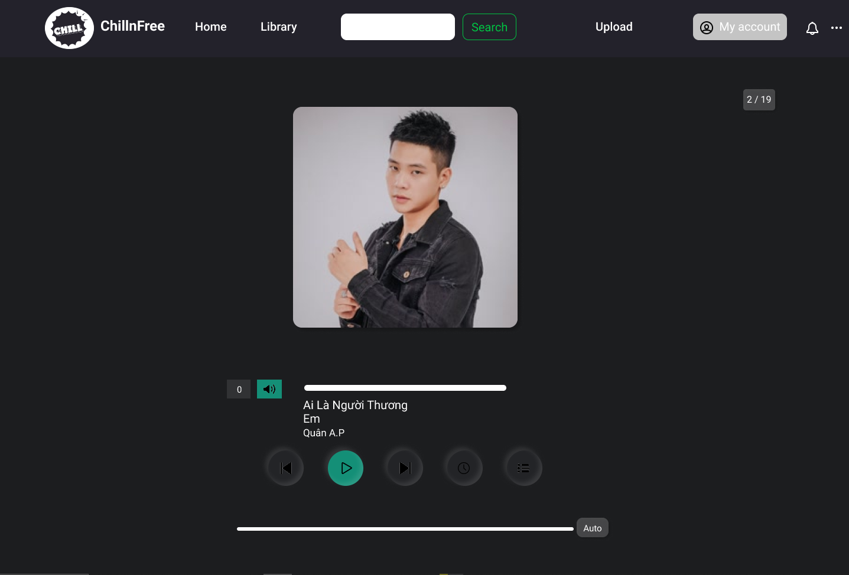

Description: This is the play music page that contains: Image of the song, volumn, mute/unmute button, previous song button, play/pause button, next song button, open Pomodoro timer button, open playlist button and duration of the song.

Flow 2:

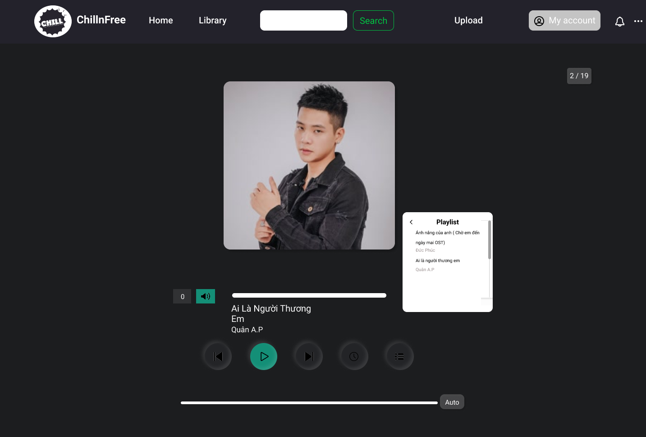

Description: This is the play music page that includes playlist when user press “Open playlist button

Flow 3:

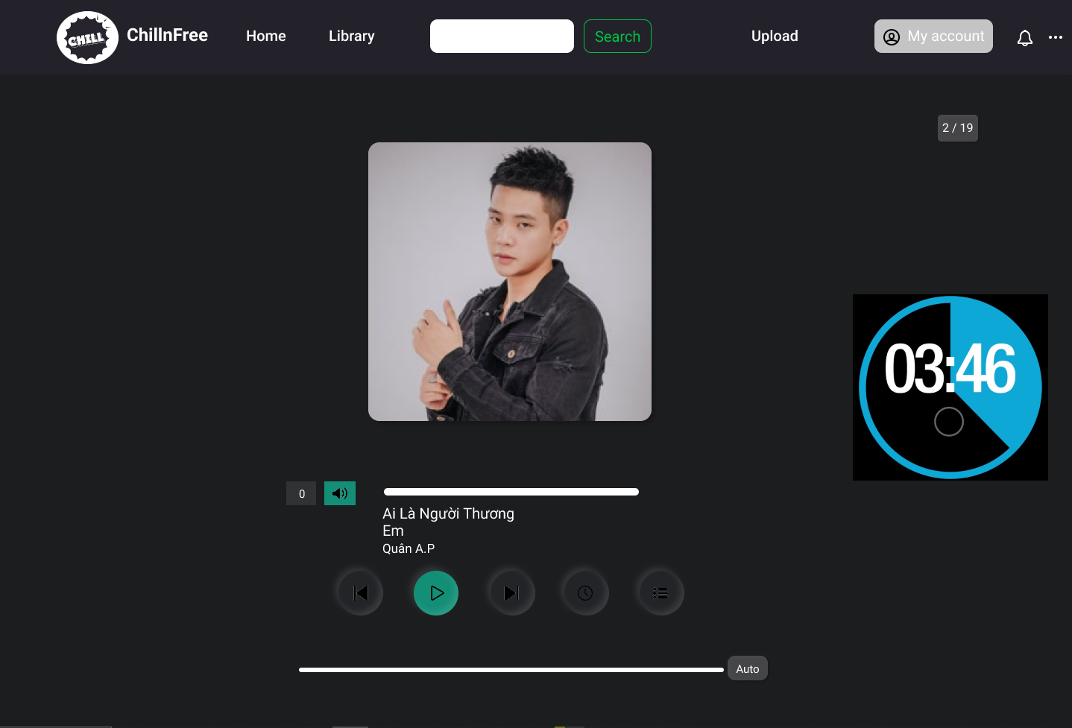

Description: This is the play music page that includes a Pomodoro timer when the user clicks the Open pomodoro button.

# Sign in/Sign up

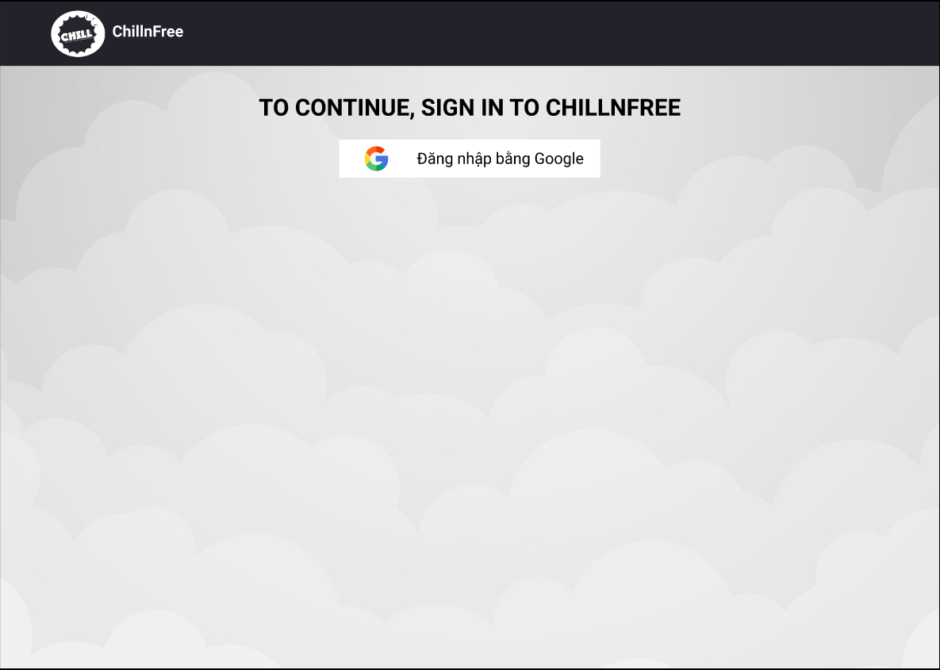

Description: To login and register on the ChillnFree website, users need to create a Google account or use a pre-register account and click the login button in the middle of the website screen. After successful login, the system will redirect the user to the home page for users.

# Upload a song

Flow 1:

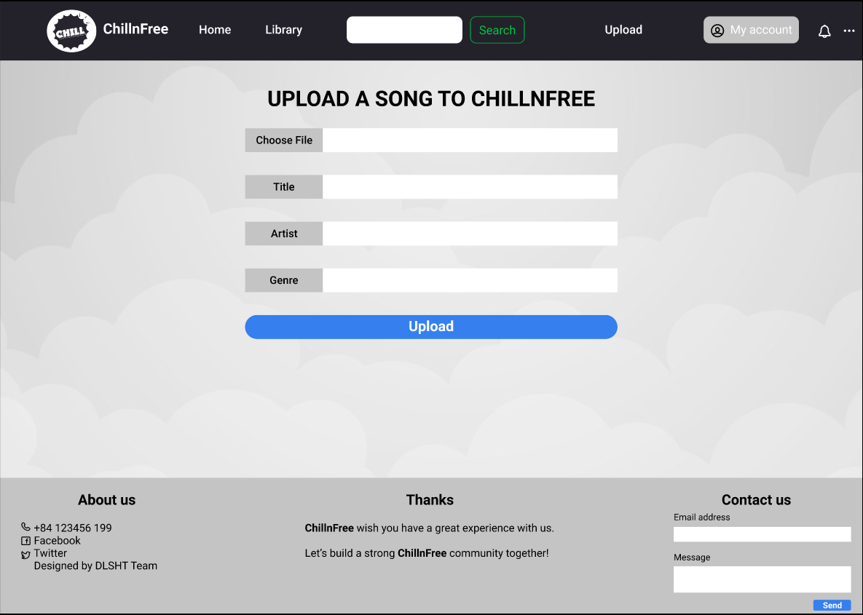

Description: This is a page used to upload music on the user's computer to the system. User will click on the “Choose File” button to select the music file already on the computer.

Flow 2:

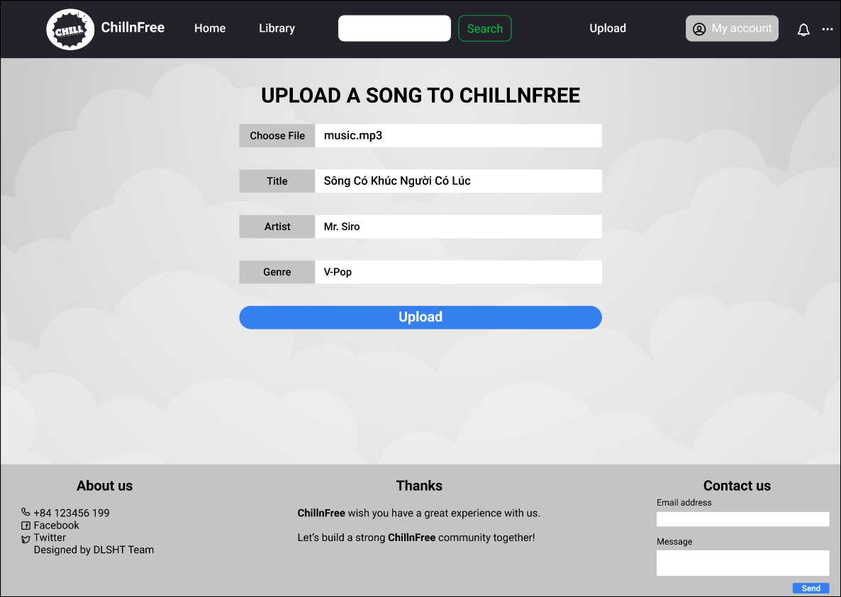

Description: When the user has selected the music file to upload, the system will record the information of that file such as song name, artist name, music genre and upload to the database.

Flow 3:

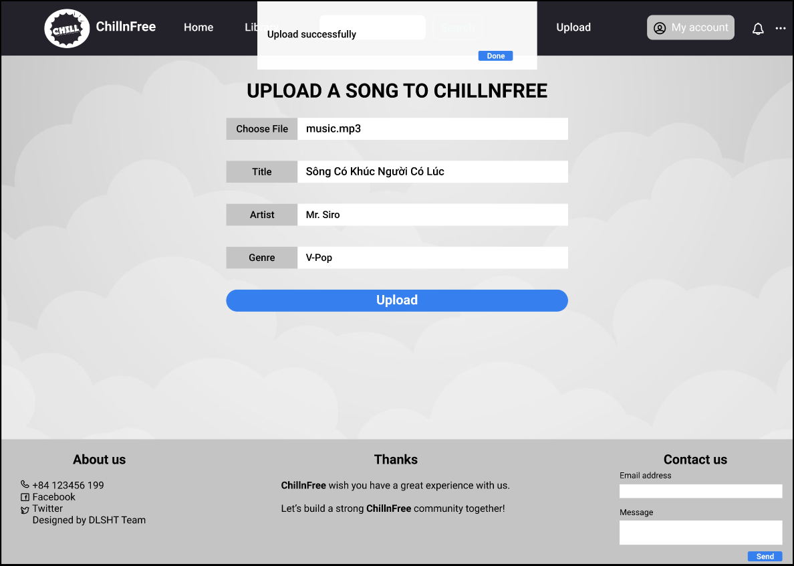

Description: When the user has confirmed the file to be uploaded and clicked the “Upload” button. The system will record whether the file has been uploaded or not and return a notification to the user